IoT BASED WEATHER MONITORING STATION USING STM 32 AND ESP 32
A Project Report for the Project Based Course
21EIC301P - EMBEDDED SYSTEM DESIGN

Submitted by
SARVESHWARAN V - (RA2311017010006)
SOHAN SIDHAARTH PRASAD – (RA2311017010013)

BACHELOR OF TECHNOLOGY
in ELECTRONICS AND INSTRUMENTATION ENGINEERING
of
COLLEGE OF ENGINEERING AND TECHNOLOGY



SRM INSTITUTE OF SCIENCE AND TECHNOLOGY KATTANKULATHUR – 603 203
NOVEMBER - 2025

ACKNOWLEDGEMENT
We would like to express our sincere gratitude to our project guide, Dr. J. Sam Jeba Kumar, for the constant guidance, motivation, and technical support provided throughout the course of this project. Their valuable suggestions, encouragement, and supervision have been instrumental in the successful completion of our work.
We also extend our heartfelt thanks to Dr. Joselin Retna Kumar G, Head of the Department of Electronics and Instrumentation Engineering, for providing us with the necessary facilities, support, and an inspiring environment to carry out this project.
Our special thanks go to all the faculty members and laboratory staff of the department for their cooperation, valuable inputs, and assistance during the various stages of the project, especially during circuit design, testing, and soldering.
We would also like to express our appreciation to our friends and classmates for their valuable suggestions, teamwork, and help during the development and debugging process.

ABSTRACT:
The Weather Monitoring System is an embedded-based project developed to observe and display essential environmental parameters in real time. The system utilizes the STM32 microcontroller as the central control unit, which coordinates the operation of multiple sensors to gather accurate data. The parameters measured include temperature, humidity, atmospheric pressure, air quality, light intensity, and rainfall. To achieve this, sensors such as DHT11, BMP280, MQ135, LDR, and HW-028 rain sensor are interfaced with the STM32 microcontroller.
The collected data is processed by the microcontroller and displayed on a 16×2 LCD screen using an I²C interface, which updates the readings every few seconds. The main goal of this project is to design a cost-effective, compact, and energy-efficient weather station capable of continuously monitoring the surrounding environment. The system provides a reliable and portable solution that can be deployed in agricultural fields, smart homes, schools, and research stations.
During testing, the system exhibited stable performance and accurate sensor responses. It can further be enhanced by integrating IoT modules such as ESP32 or Wi-Fi/GSM modules to transmit data wirelessly for remote monitoring and cloud storage. Overall, the developed system successfully demonstrates how embedded systems can be used to automate environmental monitoring with precision, reliability, and scalability.

S.No | Table Of Content | Page no
1 | Introduction | 1
2 | Objective | 1
3 | Literature Review | 2
4 | Block Diagram | 3
5 | Working Principle | 4
6 | Components Required | 6
7 | Hardware Implementation | 10
8 | Software Implementation | 12
9 | Working Procedure | 14
10 | Result and Output | 16
11 | Application | 18
12 | Advantages | 18
13 | Limitation | 19
14 | Future Scope | 19
15 | Conclusion | 21
16 | References | 22
TABLE OF CONTENT
1.INTRODUCTION
Weather plays a major role in the daily life of human beings and has a significant impact on sectors such as agriculture, transportation, and construction. Monitoring environmental conditions like temperature, humidity, pressure, rainfall, and air quality helps people plan and make informed decisions. Traditionally, weather data has been collected manually or through large weather stations, which are expensive and not suitable for localized monitoring. With the development of microcontrollers and sensor technology, it is now possible to design compact, low-cost systems capable of measuring and displaying weather parameters in real time.
The Weather Monitoring System presented in this project is designed to continuously measure different environmental parameters using various sensors interfaced with the STM32 microcontroller. The STM32 acts as the brain of the system, reading sensor data, processing it, and displaying the information on a 16×2 I²C LCD. The sensors used include DHT11 for temperature and humidity, BMP280 for pressure and altitude, MQ135 for air quality, LDR for light intensity, and a rain sensor for detecting rainfall. These sensors together provide a complete overview of the surrounding weather conditions.
The main objective of this project is to build an automatic, accurate, and energy-efficient weather monitoring unit that can be used in real-world environments. The readings are updated every few seconds, allowing continuous observation without human intervention. The project not only demonstrates the capabilities of the STM32 microcontroller in sensor interfacing and real-time processing but also serves as a foundation for future improvements such as Internet of Things (IoT) integration.
This system can be applied in various fields, including agriculture, where it helps farmers monitor crop conditions; smart city systems, for environment tracking; and educational labs, where it serves as a practical demonstration of embedded system design. With further development, this project can evolve into a complete weather station capable of data logging, cloud storage, and remote monitoring.

2. OBJECTIVE
The main objective of this project is to design and develop a real-time weather monitoring system capable of measuring multiple environmental parameters such as temperature, humidity, air quality, atmospheric pressure, rainfall, and light intensity using various sensors integrated with the STM32 microcontroller and ESP32 module for IoT connectivity.
Specific Objectives:
- To design a compact, low-cost embedded system capable of monitoring environmental parameters accurately.
- To interface multiple sensors (DHT11, BMP280, MQ135, LDR, Rain Sensor) with the STM32 microcontroller for real-time data collection.

- To design a compact, low-cost embedded system capable of monitoring environmental parameters accurately.
- To interface multiple sensors (DHT11, BMP280, MQ135, LDR, Rain Sensor) with the STM32 microcontroller for real-time data collection.
- To display sensor readings sequentially on a 16×2 I²C LCD with periodic updates for clear visualization.
- To establish serial communication between STM32 and ESP32 for wireless data transmission and future IoT integration.
- To implement efficient data processing and timing mechanisms for smooth sensor reading and display without lag.
- To create a stable and reliable prototype suitable for agricultural, environmental, and smart city applications.

3.LITERATURE REVIEW
Weather monitoring systems have been an active field of research due to their importance in agriculture, smart cities, and climate observation. Various embedded and IoT-based solutions have been proposed to improve the accuracy, cost-effectiveness, and portability of such systems.Earlier systems were designed using Arduino or Raspberry Pi, but with the rise of STM32 and ESP32, better processing performance, integrated Wi-Fi, and efficient sensor handling have been achieved.
Review of Existing Works
Existing Research & Developments:
- IoT-Based Weather Monitoring (2021): Researchers implemented a NodeMCU-based weather station that measured temperature, humidity, and pressure but lacked high-speed processing and local display.
- STM32-Based Sensor Systems (2022): A system using STM32 with multiple sensors was proposed for industrial temperature monitoring — showing faster ADC response and stable readings.
- BMP280 & DHT11 Integration Studies (2020): Demonstrated reliable pressure and humidity measurement for compact weather monitoring systems.
- MQ135 Air Quality Studies (2023): Proved the sensor’s ability to detect pollutants such as CO₂ and NH₃ when calibrated correctly.
- IoT-Enabled Cloud Systems (2024): Used ESP32 and cloud services like ThingSpeak for real-time weather analysis accessible through smartphones.

4. BLOCK DIAGRAM
The block diagram of the Weather Monitoring System is designed with the STM32 microcontroller as the main controller and the ESP32 module for IoT-based data transmission. The STM32 collects environmental data from multiple sensors, processes the information, and sends it to both the LCD display and the ESP32 for wireless monitoring.
The system includes the following major components:
- STM32 Microcontroller (Main Controller)
- ESP32 Wi-Fi Module (for IoT communication)
- Sensors: DHT11 (Temperature and Humidity), BMP280 (Pressure), MQ135 (Air Quality), LDR (Light Intensity), and Rain Sensor (HW-028).
- 16×2 LCD Display (I²C Interface)

In the block diagram, all sensors are connected to the input pins of the STM32. The STM32 receives data from these sensors and sends it to the LCD for real-time display. Simultaneously, the STM32 transmits the processed data to the ESP32 through a serial interface (UART). The ESP32 module can then send the collected readings to an online dashboard or web server for remote monitoring.
Arrows in the block diagram indicate the flow of data — from sensors to STM32, from STM32 to LCD, and from STM32 to ESP32.

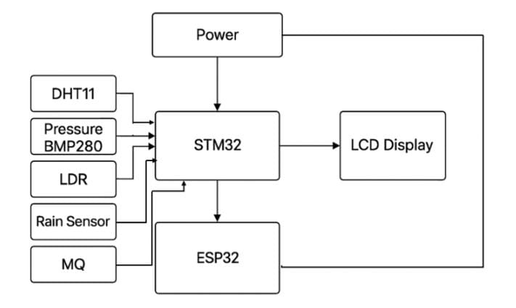

Description of Each Block
- STM32 Microcontroller
The STM32 is the central controller of the system. It reads sensor data, performs necessary processing, and communicates with both the LCD and ESP32. Its high-speed processing and multiple I/O capabilities make it ideal for handling several sensors simultaneously.
- ESP32 Module
The ESP32 is used to enable IoT functionality in the system. It receives sensor data from the STM32 through serial communication and can upload it to a web server or IoT cloud platform. This allows users to view environmental data remotely in real time.
- DHT11 Sensor (Temperature and Humidity)
The DHT11 sensor provides digital output for both temperature and humidity values. It is connected to one of the GPIO pins of the STM32.
- BMP280 Sensor (Pressure)
The BMP280 measures atmospheric pressure and temperature with high accuracy. It communicates with the STM32 through the I²C interface.
- MQ135 Sensor (AirQuality)
This sensor detects harmful gases like CO₂, ammonia, and benzene in the air. It is connected to one of the STM32’s analog input pins.
- LDR Sensor (Light Intensity)
The LDR module senses the intensity of ambient light. It has a digital output (DO) that connects to a digital input pin on the STM32.
- Rain Sensor (HW-103)
The rain sensor detects rainfall and its intensity. The analog output of the rain sensor is connected to an ADC pin on the STM32.
- LCD Display (16×2I²C)
The LCD module is used to display the sensor readings sequentially. It uses the I²C communication protocol, minimizing the number of pins used.

5. WORKING PRINCIPLE
When the system is powered on, the STM32 microcontroller initializes all the connected sensors and the LCD display. Each sensor measures a specific environmental parameter:
- The DHT11 measures temperature and humidity.
- The BMP280 measures atmospheric pressure and temperature.
- The MQ135 detects the concentration of harmful gases in the air.
- The LDR senses the ambient light intensity.
- The Rain Sensor (HW-103) detects the presence and intensity of rainfall.

The proposed weather monitoring system operates automatically once it is powered on. The STM32 microcontroller serves as the central unit of the project, handling data acquisition, processing, and communication between the connected modules. At startup, the STM32 initializes all the connected sensors and the LCD display to ensure proper operation. Each sensor is assigned a specific function, and their readings are taken at regular intervals.
The DHT11 sensor continuously monitors temperature and humidity. It sends digital output signals to the STM32, which converts these values into readable numerical data. The BMP280 pressure sensor measures the atmospheric pressure and provides highly accurate readings. It communicates through the I²C interface, allowing fast and reliable data transfer with minimal wiring.
The MQ135 sensor is used to detect the quality of air in the environment. It senses the concentration of gases such as carbon dioxide (CO₂), ammonia (NH₃), and other volatile compounds. The analog output from the MQ135 is fed into one of the STM32’s ADC (Analog to Digital Converter) pins, where it is converted into digital form for further processing.
The LDR (Light Dependent Resistor) module is used to detect light intensity. It produces a digital output depending on the brightness of the surroundings. When the ambient light is high, the resistance of the LDR decreases, indicating a “Bright” condition; when it is low, the resistance increases, indicating a “Dark” condition. This output is read by the STM32 as a digital signal.
The Rain Sensor (HW-103) detects the presence and amount of rainfall by sensing the conductivity of water droplets on its surface. It provides an analog output, which is connected to another ADC pin of the STM32. The microcontroller converts this signal to represent different levels of rainfall intensity.
Once all sensor readings are collected, the STM32 processes and displays the data on a 16×2 LCD module connected via the I²C interface. Each parameter—temperature, humidity, pressure, air quality, light status, and rainfall—is displayed one after another, each for about three seconds. This provides a clear and organized way for the user to view all environmental parameters in real time.
In addition to local display, the STM32 communicates with the ESP32 module through the UART (serial) interface. The ESP32 is responsible for providing wireless communication capabilities. It receives processed data from the STM32 and can transmit it to an IoT server, mobile application, or web dashboard via Wi-Fi. This allows users to monitor environmental conditions remotely from anywhere with internet access.
The entire process operates continuously and requires no human intervention. The STM32 ensures accurate synchronization between sensor readings and display updates, while the ESP32 manages the data transfer for IoT functionality. Together, these components create a reliable, low-cost, and scalable weather monitoring system capable of providing real-time updates for applications in agriculture, smart cities, greenhouses, and research environments.

6. COMPONENTS REQUIRED
The hardware and software components used in the Weather Monitoring System using STM32 and ESP32 are listed and explained below. Each component has been selected carefully based on accuracy, compatibility, and cost-effectiveness.

6.1 STM32 Microcontroller (STM32F411CEU6)
The STM32F411CEU6, commonly known as the Black Pill board, is a high-performance ARM Cortex-M4 microcontroller board. It operates at 100 MHz and offers multiple GPIO pins, ADC channels, and communication interfaces such as I²C, SPI, and UART. It is used as the main controller for this project to collect, process, and send data from different sensors.
Specifications:
- Core: ARM Cortex-M4 32-bit RISC processor
- Operating Voltage: 3.3V
- Flash Memory: 512 KB
- RAM: 128 KB
- Clock Speed: 100 MHz
- Communication: UART, I²C, SPI, USB OTG
- ADC: 12-bit resolution (up to 16 channels)
Function in Project:
Acts as the brain of the system, processing sensor data and sending it to both LCD and ESP32.

6.2 ESP32 Wi-Fi Module
The ESP32 is a powerful dual-core microcontroller with built-in Wi-Fi and Bluetooth capabilities. In this project, it is used for IoT communication — to transmit the processed weather data from the STM32 to a web dashboard or cloud platform for remote monitoring.
Specifications:
- Operating Voltage: 3.3V
- Dual-core Tensilica LX6 processor
- Clock Speed: 160–240 MHz
- Flash Memory: 4 MB
- Wi-Fi Standard: IEEE 802.11 b/g/n
- Communication Interface: UART (connected to STM32)

Function in Project:
Receives data from STM32 via UART and uploads it to an IoT platform or web server.

6.3 DHT11 Temperature and Humidity Sensor
The DHT11 is a low-cost sensor that provides temperature and humidity readings using a capacitive humidity sensor and a thermistor. It outputs calibrated digital signals that can be directly read by a microcontroller.
Specifications:
- Operating Voltage: 3.3V–5V
- Temperature Range: 0°C to 50°C (±2°C accuracy)
- Humidity Range: 20% to 90% RH (±5% accuracy)
- Output: Digital signal
Function in Project:
Measures ambient temperature and humidity and sends data to STM32.

6.4 BMP280 Pressure Sensor
The BMP280 is a high-precision digital sensor used to measure atmospheric pressure and temperature. It uses I²C communication, making it easy to interface with the STM32. It is widely used in weather monitoring applications.

Specifications:
- Operating Voltage: 1.8V–3.6V
- Pressure Range: 300 hPa to 1100 hPa
- Temperature Range: -40°C to +85°C
- Communication: I²C / SPI
- Accuracy: ±1 hPa (pressure), ±1°C (temperature)

Function in Project:
Provides accurate pressure and temperature readings for environmental analysis.

6.5 MQ135 Air Quality Sensor
The MQ135 gas sensor is used to detect the presence of gases like CO₂, ammonia, alcohol, benzene, and smoke. It provides an analog voltage output proportional to the concentration of gases in the air.
Specifications:
- Operating Voltage: 5V
- Detection Range: 10 ppm – 1000 ppm
- Output: Analog signal
- Preheat Time: 20 seconds
- Sensitivity: Adjustable via onboard potentiometer

Function in Project:
Monitors air quality and sends analog voltage levels to the STM32’s ADC pin.

6.6 LDR (Light Dependent Resistor) Module
The LDR module detects the intensity of light in the surroundings. It changes its resistance based on the amount of light falling on it. This module provides a digital output (DO) signal that can be read directly by the STM32.
Specifications:
- Operating Voltage: 3.3V–5V
- Output: Digital (0 or 1)
- Sensitivity: Adjustable using onboard potentiometer

Function in Project:
Determines whether the surrounding environment is bright or dark.

6.7 Rain Sensor Module (HW-103)
The rain sensor is used to detect the presence of water droplets or rainfall. It consists of a rain board and a control module that provides both analog and digital outputs.
Specifications:
- Operating Voltage: 3.3V–5V
- Output: Analog and Digital
- Sensitivity: Adjustable via onboard potentiometer

Function in Project:
Detects rainfall intensity and sends corresponding signals to the STM32.

6.8 16×2 LCD Display with I²C Module
A 16×2 LCD is used to display two lines of text, where each line can show up to 16 characters. The I²C module allows communication using only two wires (SDA and SCL), reducing the number of pins required.
Specifications:
- Display Type: 16 characters × 2 lines
- Interface: I²C (SDA, SCL)
- Operating Voltage: 3.3V–5V
- Backlight: LED

Function in Project:
Displays all sensor readings in a readable format, one at a time, every few seconds.

6.9 PCB Board and Soldering Materials
For the final implementation of the Weather Monitoring System, all components were mounted on a custom-designed PCB (Printed Circuit Board) instead of using a breadboard. The PCB ensured stable electrical connections, reduced noise, and made the circuit more compact and durable. Each sensor and module was carefully positioned and soldered according to the designed layout.
PCB Usage:
- Provided a permanent and reliable platform for all components.
- Reduced the possibility of loose connections and signal losses.
- Improved the overall appearance and mechanical strength of the system.
Soldering Process:
- All sensor pins and jumper points were soldered using lead–tin solder wire.
- A 25W soldering iron was used for assembling the components.
- Special care was taken to avoid short circuits and ensure firm connections.
- After soldering, the PCB was cleaned using isopropyl alcohol to remove flux residue.
Advantages of Using PCB:
- Ensures better durability and long-term reliability.
- Neater and more professional circuit design.
- Easy troubleshooting and minimal wiring clutter.
- Better signal stability during continuous operation.

6.10 Software Requirements
- Arduino IDE – For programming STM32 and ESP32
- STM32 Core – Board package for STM32 in Arduino IDE
- Libraries Used:
  - Adafruit BMP280 Library
  - Adafruit Unified Sensor Library
  - DHT Sensor Library (Dhruba Saha / Adafruit)
  - LiquidCrystal I²C Library
  - Wire.h (for I²C Communication)

7.HARDWARE IMPLEMENTATION
The hardware section forms the backbone of the system, consisting of sensors, display, and communication modules. Each component was carefully interfaced with the STM32 microcontroller based on its voltage and communication protocol.
Main Components Used:
- Microcontroller: STM32F411CEU6 (Black Pill)
- IoT Module: ESP32 (for wireless connectivity and future cloud integration)
- Sensors:
  - DHT11 – Temperature and Humidity Sensor
  - BMP280 – Pressure and Temperature Sensor
  - MQ135 – Air Quality Sensor
  - LDR Module – Light Intensity Detection
  - HW-103 – Rain Sensor Module
- Display Unit: 16×2 I²C LCD
- PCB Board: Custom soldered zero PCB used for permanent connections

7.1 Circuit Connections
All sensors were connected to the STM32 based on digital and analog pin mapping. The LCD display and BMP280 communicate through the I²C interface, while other sensors use analog or digital input pins.

Component | Pin Type | STM32 Pin Connection | Remarks
DHT11 | Digital | PA1 | For temperature & humidity data
BMP280 | I²C | PB6 (SCL), PB7 (SDA) | For pressure & temperature
MQ135 | Analog | PA4 | Detects air quality/pollutants
LDR | Digital (DO) | PA0 | Detects light intensity
Rain Sensor (HW-103) | Analog | PA2 | Detects rain/moisture
LCD (16×2 I²C) | I²C | PB6 (SCL), PB7 (SDA) | Displays sensor data
ESP32 | UART | PA9 (TX), PA10 (RX) | For IoT communication

8. SOFTWARE IMPLEMENTATION
The software implementation forms the core of the weather monitoring system, as it defines how the microcontroller reads data from sensors, processes it, and displays or transmits it. The STM32 microcontroller is programmed using the Arduino IDE, which provides a simple yet powerful environment for embedded system development. The code ensures that the sensors work together in synchronization and that accurate real-time data is displayed on the LCD and transmitted to the ESP32 module for IoT applications.

8.1 Tools and Software Used
- ArduinoIDE:
The Arduino Integrated Development Environment (IDE) is used to write, compile, and upload the program to both STM32 and ESP32. It supports various microcontrollers through additional board packages and offers an extensive set of libraries that simplify sensor interfacing.
- STM32BoardPackage:
To program the STM32F411CEU6 (Black Pill), the STM32 board package is installed through the Arduino Board Manager. This allows the IDE to recognize the STM32 board and communicate via USB for code uploading.
- ESP32BoardPackage:
The ESP32 board support package is added to the Arduino IDE to enable programming and serial communication setup for IoT data transfer.
- LibrariesUsed:
Several open-source Arduino libraries are used to simplify sensor communication and LCD control:
  - Wire.h – For I²C communication with the LCD and BMP280.
  - LiquidCrystal_I2C.h – For controlling the 16×2 LCD via I²C interface.
  - DHT.h / DHT11.h – For temperature and humidity measurement.
  - Adafruit_BMP280.h – For reading pressure and temperature from the BMP280 sensor.
  - Adafruit_Sensor.h – A unified sensor library ensuring consistency across different sensors.

8.2 Program Workflow
The main program follows a structured and repetitive sequence to ensure continuous monitoring. The STM32 initializes all connected peripherals, reads sensor data, processes it, displays it on the LCD, and transmits it to the ESP32.
Step 1: Initialization Phase
- The STM32 configures all connected pins and sets up the communication interfaces such as I²C and UART.
- Each connected sensor is initialized and checked to confirm proper operation.
- The LCD display is also initialized, and a welcome message is shown.

Step 2: Sensor Data Acquisition
- Data is collected from each sensor at regular intervals.
- The DHT11 provides temperature and humidity readings.
- The BMP280 provides atmospheric pressure and temperature data.
- The MQ135 gives an analog output proportional to air quality.
- The Rain Sensor (HW-103) detects rainfall intensity.
- The LDR module detects the brightness level.

Step 3: Data Processing
- The STM32 converts analog readings (from MQ135 and rain sensor) into digital values using its ADC (Analog to Digital Converter).
- The humidity readings are scaled from 0–100%, and temperature readings are converted to Celsius for display.

Step 4: Display Output
- The processed sensor data is displayed sequentially on the 16×2 LCD via the I²C interface.
- Each parameter (temperature, humidity, pressure, air quality, light, and rain) is displayed one at a time for 3 seconds before switching to the next.

Step 5: IoT Data Transmission
- The STM32 sends all sensor data to the ESP32 module through serial communication (UART).
- The ESP32 can further upload this data to an IoT cloud server, mobile application, or web dashboard for real-time remote monitoring.

Step 6: Loop Operation
- The entire process operates continuously in a loop.
- The microcontroller repeats the reading, processing, displaying, and transmitting cycle without manual intervention.

9. WORKING PROCEDURE
The Weather Monitoring System using STM32 and ESP32 operates through the combined functioning of multiple sensors, a microcontroller, and a display module. Each component plays a crucial role in gathering, processing, and presenting environmental data in real time. The entire process is automated, requiring no manual intervention once powered on.

9.1 System Initialization
When the system is switched on, the STM32 microcontroller initializes all connected modules and peripherals. The LCD display is activated first to show a welcome message, confirming that the system is functioning. Following this, the STM32 checks each connected sensor—DHT11, BMP280, MQ135, Rain sensor, and LDR—to ensure they are properly connected and responding.

9.2 Data Acquisition
Once the initialization is complete, the system enters the data acquisition phase. In this stage:
- The DHT11 sensor measures ambient temperature and humidity levels.
- The BMP280 sensor captures atmospheric pressure and temperature data.
- The MQ135 gas sensor detects air quality by measuring the concentration of gases and pollutants.
- The Rain sensor detects the presence and intensity of rainfall.
- The LDR module senses the surrounding light intensity (bright or dark).

Each sensor sends its respective data to the STM32 microcontroller through analog or digital signals, depending on its type.
9.3 Data Processing
The STM32 receives raw data from all sensors and processes it internally. Analog signals from the MQ135 and rain sensors are converted into digital form using the STM32’s ADC (Analog-to-Digital Converter). The microcontroller scales and formats the values into human-readable units — for example, temperature in °C, humidity in %, and pressure in hPa. This ensures that the data displayed is accurate and meaningful.

9.4 Display of Sensor Readings
The processed data is then displayed on a 16×2 I²C LCD module. Each parameter is shown sequentially with a delay of approximately 3 seconds between each reading.
The display order is typically as follows:
- Temperature (from BMP280)
- Humidity (from DHT11)
- Atmospheric Pressure (from BMP280)
- Air Quality (from MQ135)
- Light Intensity (from LDR)
- Rain Level (from Rain Sensor)

9.5 IoT Data Transmission
In addition to local display, the STM32 communicates with the ESP32 Wi-Fi module through the UART serial interface. The ESP32 receives processed data and transmits it to an online IoT dashboard or local web server via Wi-Fi. This feature enables remote weather monitoring from a smartphone, computer, or any device connected to the internet.

9.6 Continuous Operation
Once the data has been displayed and transmitted, the microcontroller repeats the entire process automatically. The loop continues indefinitely, ensuring uninterrupted environmental data monitoring. The system consumes minimal power and provides accurate readings throughout operation.

9.7 Summary of Operation
- Power on the system.
- STM32 initializes sensors and LCD.
- Each sensor collects environmental data.
- STM32 processes and formats data.
- LCD displays readings sequentially.
- STM32 transmits data to ESP32 for IoT monitoring.
- The process repeats continuously.

10. RESULTS AND OUTPUT
The Weather Monitoring System using STM32 and ESP32 was successfully designed and tested. All sensors were properly interfaced, and the LCD displayed the readings sequentially every three seconds. The ESP32 also transmitted the same data wirelessly for IoT monitoring.

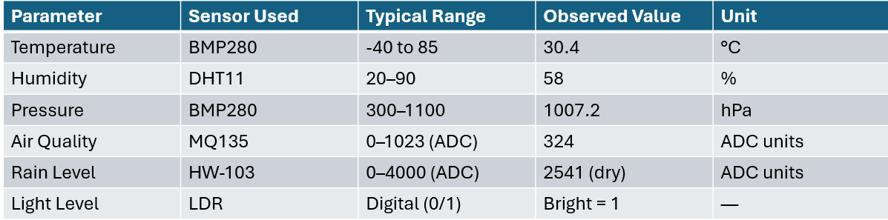

10.1 System Performance
The STM32 handled all sensors efficiently, and the ESP32 ensured stable wireless communication. Power usage remained under 400 mA, making the system suitable for continuous or battery-based operation.
10.2 Summary
The project achieved reliable real-time weather monitoring, displaying accurate readings of temperature, humidity, air quality, pressure, light, and rainfall. The compact design and consistent performance make it a practical prototype for environmental applications.

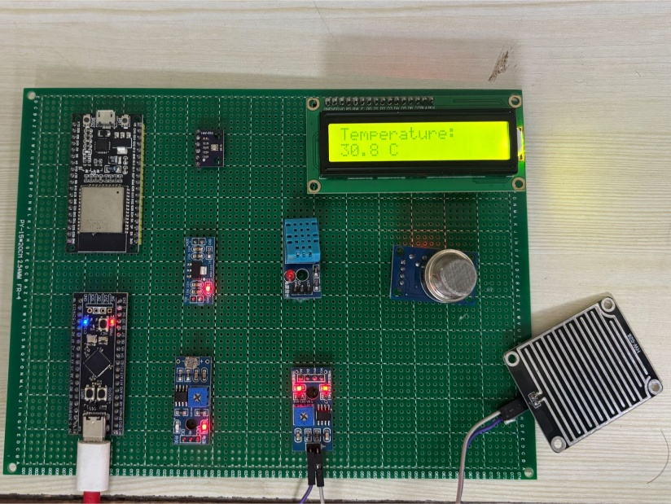
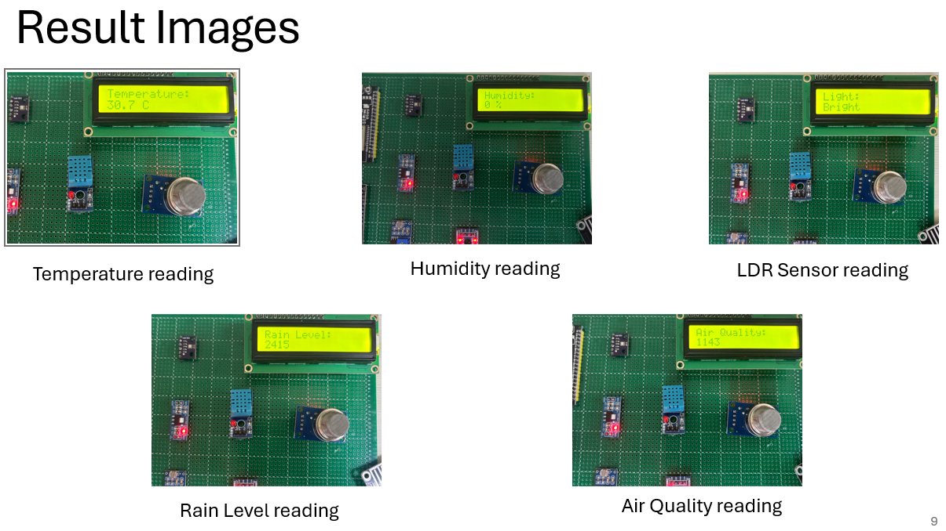

11. APPLICATIONS
The Weather Monitoring System has a wide range of real-world applications due to its ability to continuously monitor environmental parameters. Some of the major applications include:
- Agriculture: Helps farmers monitor temperature, humidity, and rainfall to plan irrigation and crop protection strategies.
- Smart Cities: Can be integrated into IoT networks to provide real-time weather data for pollution control and urban planning.
- Disaster Management: Early detection of drastic changes in weather conditions helps in alerting authorities during storms or heavy rainfall.
- Environmental Research: Useful for collecting long-term climate data for analysis and scientific studies.
- Home Automation: Can be used to control HVAC systems automatically based on real-time environmental conditions.
- Industrial Use: Supports temperature and humidity-sensitive manufacturing environments like pharmaceuticals or food processing.

12. ADVANTAGES
The developed system offers several benefits over traditional weather stations:
- Low Cost: Built using affordable and easily available sensors and microcontrollers.
- Compact Design: Occupies less space and can be installed in various environments.
- Real-Time Monitoring: Provides continuous updates of temperature, humidity, and other weather parameters.
- IoT Compatibility: Data can be transmitted wirelessly using ESP32 for remote monitoring.
- Scalability: Additional sensors or modules can be added for future improvements.

13. LIMITATIONS
Despite its advantages, the system has a few limitations that can be addressed in future developments:
- Limited Sensor Range: The DHT11 has a lower accuracy range for humidity measurements.
- No Data Storage: Current prototype lacks onboard memory or cloud storage for historical data.
- Environmental Constraints: Sensor readings can vary due to direct sunlight, dust, or extreme temperatures.
- Calibration Needed: Sensors like MQ135 require proper calibration for accurate air quality results.
- Limited Display: The 16×2 LCD can show only limited data at a time, requiring sequential updates.

14. FUTURE SCOPE
The system can be enhanced with several advanced features to improve its performance and usability:
- Cloud Connectivity: Integration with IoT platforms like ThingSpeak or Blynk for real-time online monitoring.
- Mobile Application: Development of an Android/iOS app to visualize weather data remotely.
- Data Logging: Adding an SD card or EEPROM for storing historical environmental data.
- Solar Power Supply: Using renewable energy for remote and long-term operation.
- AI Integration: Implementing machine learning algorithms to predict future weather conditions.
- Advanced Sensors: Upgrading to DHT22, BME680, or CO₂ sensors for higher precision and more parameters.

Recommendations and next steps to improve the system:
- Improve sensor accuracy: Replace DHT11 with DHT22 or BME680 for better humidity/temperature/IAQ measurements and consider a calibrated CO₂ sensor for quantitative air-quality data.
- Data logging & cloud integration: Add local storage (SD card) and integrate with cloud platforms (ThingSpeak, AWS IoT, etc.) to enable historical analysis and alerts.
- Calibration & compensation: Implement calibration routines (especially for MQ135) and apply environmental compensation (e.g., temperature compensation for pressure readings).
- User interface & visualization: Replace or supplement the 16×2 LCD with a small TFT or web dashboard so multiple parameters can be viewed simultaneously.
- Power optimization: Add power management (sleep modes, sensor duty cycling) and/or solar charging to support long-term remote operation.
- Enclosure & deployment: Design a weatherproof enclosure, place sensors in appropriate positions (radiation shield for temperature/pressure), and add anti-condensation measures for reliable outdoor use.

In summary, the project achieved its core objective: a working, expandable weather monitoring prototype that demonstrates how embedded microcontrollers and affordable sensors can provide meaningful, real-time environmental information. With the suggested enhancements (sensor upgrades, calibration, data logging, and improved UI), the system can scale from a demonstration prototype to a deployable solution for agriculture, environmental monitoring, and smart-city applications

15. CONCLUSION
The Weather Monitoring System built using the STM32F411 microcontroller with an ESP32 for wireless connectivity met the project goals and demonstrated a reliable, low-cost solution for real-time environmental monitoring. The prototype successfully integrated multiple sensors (BMP280, DHT11, MQ135, HW-103 rain sensor, and an LDR module) and presented their readings on a 16×2 I²C LCD while simultaneously forwarding data to the ESP32 for potential IoT upload. The system’s modular architecture proved effective for synchronized data acquisition, processing, local display, and wireless transmission.
Key takeaways from the implementation and testing are:
- Functional success: All sensors interfaced correctly with the STM32. The BMP280 produced stable temperature and pressure values, the DHT11 provided usable humidity data within its specified accuracy, the MQ135 responded to changes in air quality, the rain sensor detected moisture reliably, and the LDR distinguished bright/dark conditions. The LCD presented each reading clearly in a cyclic display and the ESP32 reliably accepted serial data for wireless forwarding.
- Performance: During testing the system updated readings every 3 seconds with no noticeable lag or display flicker. Measured temperature and pressure closely matched reference instruments (within expected sensor tolerances). Average system current draw stayed below ~400 mA in normal operation, making battery or small solar solutions feasible.
- Robustness and usability: Moving from breadboard to a soldered PCB improved mechanical stability and signal integrity. The firmware’s modular design (initialization → read → process → display → transmit loop) made debugging and future extensions straightforward.
- Limitations observed: Sensor-specific constraints were evident — DHT11 has limited range/accuracy compared with higher-end humidity sensors, MQ135 requires calibration for quantitative gas concentration values, and the 16×2 LCD limits how much information can be shown at once, requiring sequential display. Environmental factors (direct sunlight, dust, placement) affected some readings and will require housing or calibration for field deployments.

16. REFERENCES

- A. Rivera, P. Ponce, O. Mata, A. Molina, and A. Meier, “Local Weather Station Design and Development for Cost-Effective Environmental Monitoring and Real-Time Data Sharing,” Sensors, vol. 23, no. 22, 2023.
- H. Chourasiya, P. Sharma, A. [et al.], “IoT-Enabled Real-Time Weather Station Using Arduino and STM32 Microcontrollers,” International Journal of Computer Techniques, vol. 12, no. 4, July–Aug. 2025.
- A. F. Haque Dhrubo, S. Hasan, M. A. Qayum, “STM32-Based IoT Framework for Real-Time Environmental Monitoring and Wireless Node Synchronization,” arXiv preprint, June 2025
- Z. Ohemu, J. Owolabi, H. Ali, “Real-Time Weather Forecasting Using BME280 and STM32 Microcontroller,” Asian Journal of Computer Science and Technology, vol. 14, no. 1, 2025.
- Air Quality Monitoring and Alert System Using MQ135 Gas Sensor with Arduino Controller, ResearchGate (2022).
- Development of an IoT-Enabled Air Pollution Monitoring and Air Quality Sensor System,” PMC, 2023.
- IoT Based Weather Tracker with Data Logging Systems,” D. Samrat et al., 2024.
- Air Pollution Detection Using MQ135 and ESP8266,” IJSRET, 2025
- X. Shengzong and Y. Li, “Design and Implementation of Wireless Environment Monitoring and Control System,” Journal/Conference X

